Name: Garima Neupane
Roll no: CSIT2081045
Subject: Statistics II Lab 1(Q11) (BSc.CSIT III Sem) Section: ‘A’

Working Expression:
The regression line of Y on X₁ and X₂ is Y = a + b₁X₁ + b₂X₂
Where, Y= dependent variable a = y-intercept
b₁ and b₂ are regression coefficients X₁ and X₂ are independent variable

Working Procedure:
Define variables Y, X1 and X2 in variable view → Assign type as Numeric → Label them as Constant, Variable 1, Variable 2→ Assign measure as Scale → Put data in data view → Analyze → Regression → Linear → Put constant in dependent list → Put Variable 1 and Variable 2 in independent → Go to statistics → Level of confidence interval 95% → continue → ok

SPSS OUTPUT:

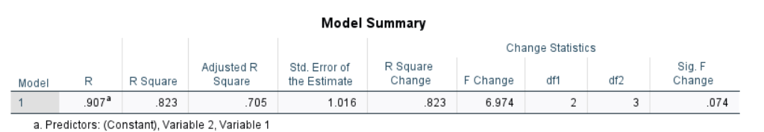

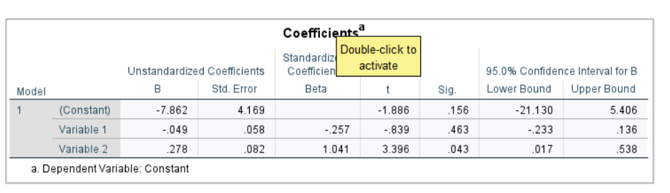

Calculation:

  - Here, a= -7.862 b₁ = -0.049
b₂ = 0.278
The multiple regression is Y = a+b₂ X₁+b₂ X₂
Y= -7.862 - 0.049 X₁ + 0.278 X₂

  - When X₁ =50, X₂ = 100
𝑌_{𝑒} = ?
𝑌_{𝑒} = -7.862 – 0.049*50 + 0.278*100
=

Hence, if someone is looking for a two bed apartment 2 miles from downtown, he should expect to pay 364.01 $ rent.

  - Multiple determination (R) = 0.196
= 91. 6%
which means that 91.6% of variation of dependent variable rent is explained by two independent variable rooms and distance.
Standard error of estimation is 97.08

Conclusion:
In general, we can obtain the estimated value of rent, coefficient of determination and standard error from the given data.

